WEEK 5
Microservices with Spring Boot 3 and Spring Cloud

Creating Microservices for account and loan:
Create directories:
- D:\<employee_id>\microservices\
Create account spring project in microservices folder:
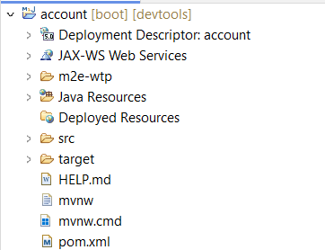

Build the project:
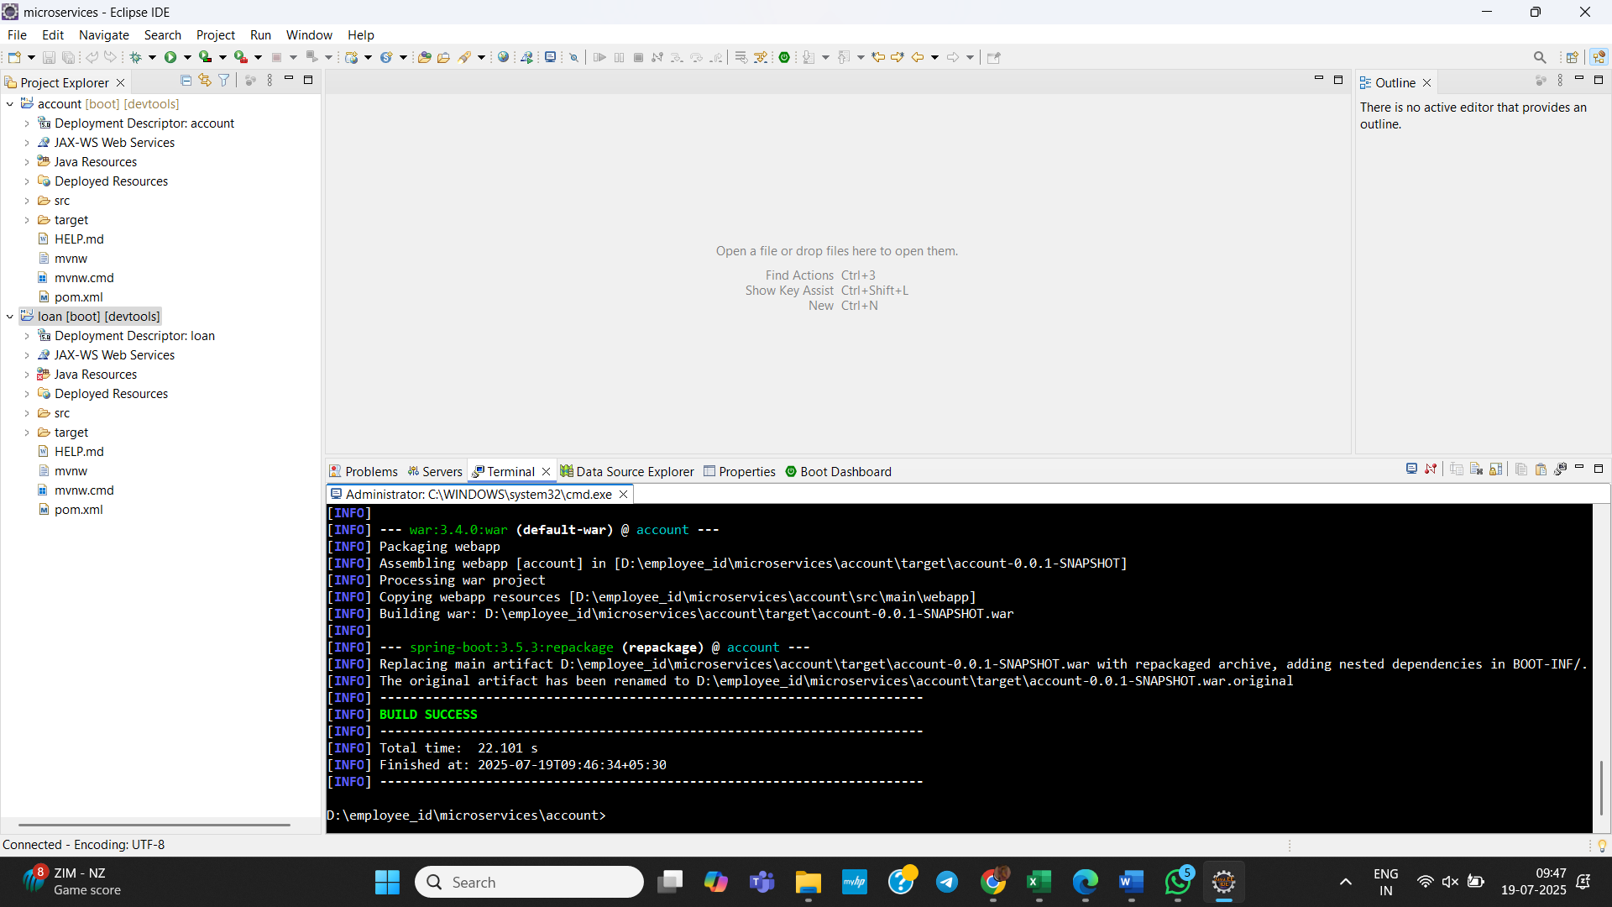

Create AccountController.java in com.cognizant.account.controller package:
package com.cognizant.account.controller;

import java.util.Map;

import org.springframework.web.bind.annotation.*;

import java.util.HashMap;

@RestController
@RequestMapping("/accounts")
public class AccountController {

@GetMapping("/{number}")
public Map<String, Object> getAccount(@PathVariable String number) {
Map<String, Object> response = new HashMap<>();
response.put("number", number);
response.put("type", "savings");
response.put("balance", 234343);
return response;
}
}

Output:
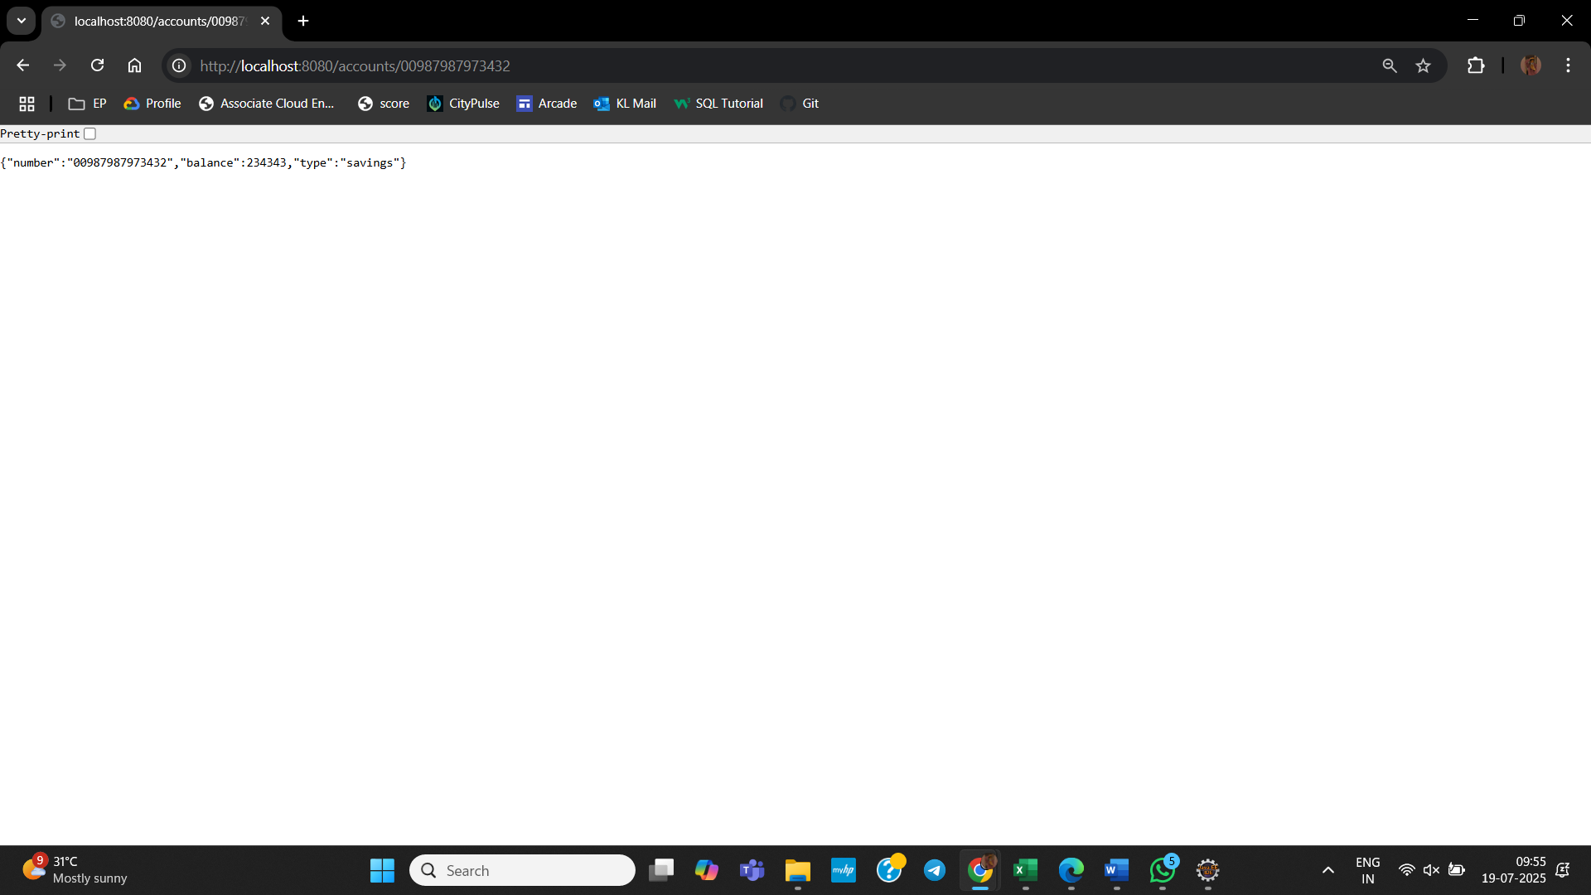
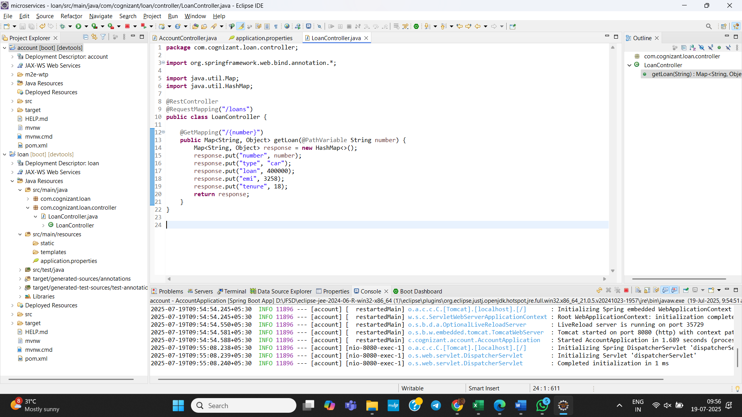

Create loan spring project in microservices folder:
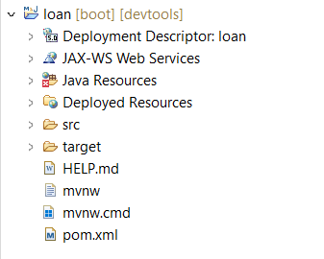

Change port to 8081 in application.properties using:
server.port=8081

Create LoanController.java in com.cognizant.loan.controller package:
package com.cognizant.loan.controller;

import org.springframework.web.bind.annotation.*;

import java.util.Map;
import java.util.HashMap;

@RestController
@RequestMapping("/loans")
public class LoanController {

@GetMapping("/{number}")
public Map<String, Object> getLoan(@PathVariable String number) {
Map<String, Object> response = new HashMap<>();
response.put("number", number);
response.put("type", "car");
response.put("loan", 400000);
response.put("emi", 3258);
response.put("tenure", 18);
return response;
}
}

Output:
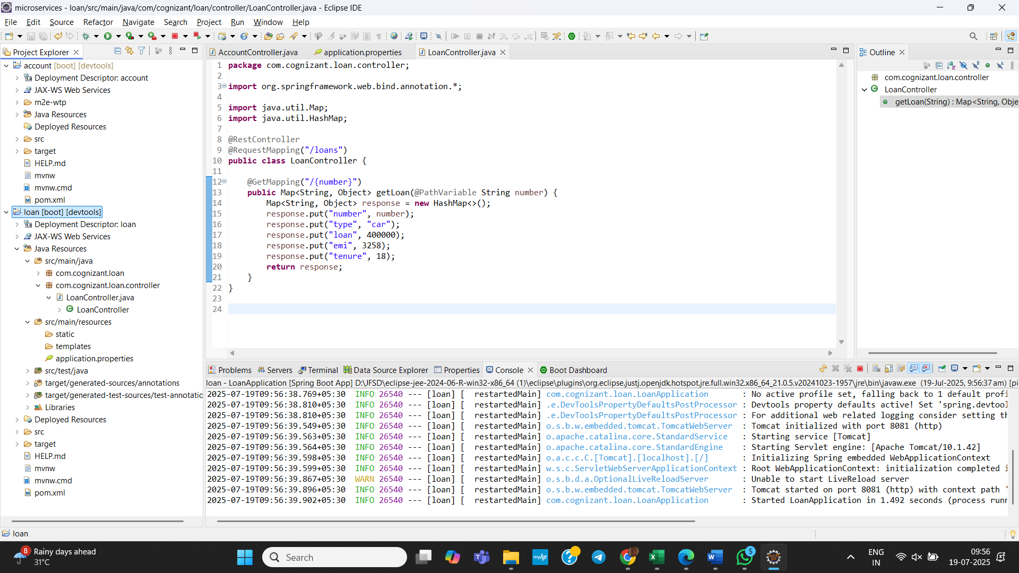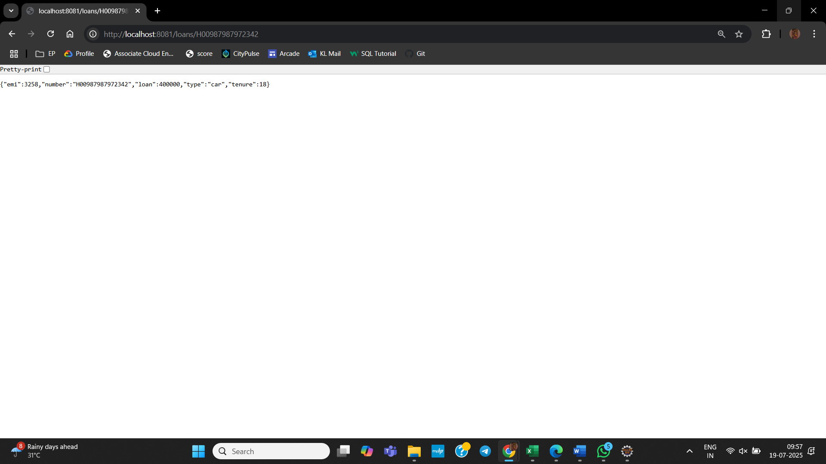

Now we have two microservices running on different ports:
